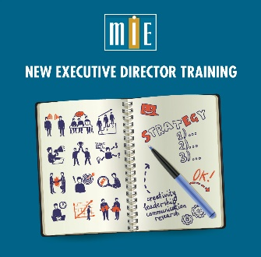

MIE New Executive Director Training
Houston, TX
Agenda

Tuesday, October 30, 2018
8:00 – 8:30 am | Continental Breakfast, Registration, Post Oak Room, 3d level
8:30 – 9:30 am | Welcome to MIE New Executive Directors Training  Introductions:  Name, Position, Program  What keeps me awake at night  What my autobiography would be called
9:30 – 10:45 am | An Effective Program
10:45 – 11:00 am | Break
11:00 – 12:15 pm | The Executive Director’s Job
12:15 – 1:45 pm | Lunch with Colleagues
1:45 – 3:15 pm | Leadership and Management
3:15 – 3:30 pm | Break
3:30 – 5:15 pm | Staff  Effective Presentations Role Play
6:00 pm | Dinner together

Wednesday, October 31, 2018
8:00 – 8:30 am | Continental Breakfast
8:30 – 8:45 am | Overnight Thoughts
8:45 – 9:45 am | Effective Presentations: Role Plays
9:45 – 10:00 am | Break
10:00 – 10:45 am | Results
10:45 – 11:30 am | Changing Program Culture
11:30 – 12:15 pm | The Executive Director’s Job Redux
12:15 – 1:45 pm | Lunch with Don Saunders, NLADA (30 minutes) or  Lunch with Colleagues
1:45 – 2:45 pm | Money
2:45 – 3:00 pm | Break
3:00 – 3:45 pm | Money
3:45 – 4:50 pm | Roundtable
4:50 – 5:00 pm | Wrap-up, Peer Support, Feedback

