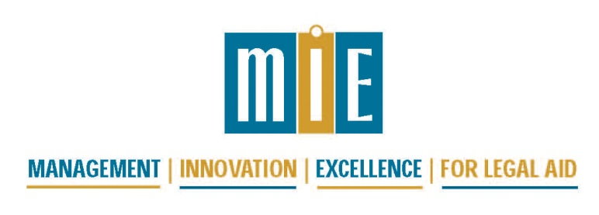

2017 National Conference for Legal Services Administrators -
“Blues, Soul, Rock ‘n Roll”

November 2 and 3, 2017
The Westin Memphis Beale Street
Memphis, TN

Agenda

Thursday, November 2, 2017
7:15 – 8:15 am | Registration and Continental Breakfast, Tennessee Ballroom Foyer
8:15 – 9:20 am | Welcome and Opening Plenary, Tennessee Ballroom  Bias and Cultural Competence in the Age of Political Incorrectness  with Harrison D. McIver III, Executive Director and CEO, Memphis Area Legal Services, and Professor Demetria D. Frank, University of Memphis Law
9:20 – 9:30 am | Move to first workshops
9:30 – 11:00 am | We Have to Talk: A Candid Approach to Difficult Conversations  Tennessee Ballroom | Knowing and Respecting Rights of Employees – Even if “The Thrill is Gone”  Buffalo |  | Making the Band: Who’s In and Who’s Out for IT and HR  Cumberland
11:00 – 11:15 am | Break
11:15 – 12:45 pm | Managing the Office Manager – Tell Me Again Why This Is Important?  Tennessee Ballroom | Case Management and Statistical Reporting – “Tell It Like It Is”  Buffalo |  |  | Retirement Plans in Legal Services – “Golden Oldies”  Cumberland
12:45 – 2:15 pm | Enjoy lunch with a colleague
2:15 – 3:45 pm | Diversity in Hiring – You Know the “Why,” Let’s Focus on the “How”—Tips and Best Practices on Implementing Diversity and Inclusion in Hiring  Buffalo |  | Someone to Watch Over Me: Successfully Navigating LSC Visits  Tennessee Ballroom
3:45 – 4:00 pm | Break
4:00 – 5:30 pm | Turn and Face the Strange Ch-ch-changes: Managing Change  Buffalo | Whole Lot of Shakin’ Goin’ On – Strategic Planning in Uncertain Times  Tennessee Ballroom |  |  | Telling Your Financial Story: Learn to Use Charts and Dashboards to Engage and Teach Board and Management  Cumberland
6:00 pm | Meet colleagues in the hotel bar for a drink and networking for dinner

Friday, November 3, 2017
7:15 – 8:15 am | Continental Breakfast, Tennessee Ballroom Foyer
8:15 – 8:45 am | A Moment to Remember Colleagues and Clients Suffering Disasters  Tennessee Ballroom
8:45 – 9:00 am | Move to workshops
9:00 – 10:30 am | Social Media Uses and Policies  Cumberland |  | LSC Regulations 1630 and 1631 –“Walk the Line”  Tennessee Ballroom
10:30 – 10:45 am | Break
10:45 – 12:15 pm | Retention – Has Legal Services Lost Its Soul or Do We Need to Find a New Way to Rock and Roll?  Cumberland | “You Know There Got to be Some Changes Made” - Triage and Intake: Towards a More Efficient and Coordinated System  Buffalo |  | “That’s All Right” - Cost Allocations in Legal Services  Tennessee Ballroom
12:15 – 1:45 pm | Enjoy lunch with a colleague
1:45 – 3:15 pm | Financial Roundtable:  Planning and Budgeting in Uncertain Times  Tennessee Ballroom | HR/Office Management Roundtable  Buffalo |  | End of the Line – Preserving the Knowledge of Key Staff Members  Cumberland
3:15 – 3:30 pm | Break
3:30 – 5:00 pm | Self-Care Is Not Selfish, You Cannot Serve from an Empty Vessel!  Cumberland |  | Legal Data Analysis and Visualization  Tennessee Ballroom
5:00 pm | Meet colleagues in the hotel bar for a drink while waiting for flights or dinner

