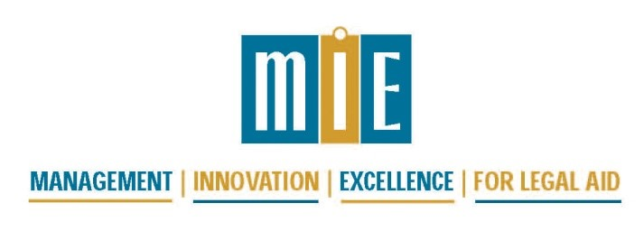
MIE 2018 Financial Training
Building Your Capacity for Solid Financial Management
Agenda (draft)

DAY 1 – Wed., Sept. 5
9:00–10:30 am | Understanding the New Accounting Standards, Tax Reporting Changes, and the 2017 New Tax Law Changes for Nonprofits
10:30–10:45am | Break
10:45–12:15 pm | Best Practices for Building and Managing Budgets |  | The Executive Director’s Role in Program Finances
12:15–1:45 pm | Lunch
1:45 – 3:15 pm | Executive Director Roundtable- Solving Fiscal Issues & Sharing Advice | Financial Software – Points of View on Several Popular Programs |  | Internal Controls- The Safeguards Your Program Cannot Live Without
3:15 – 3:30 pm | Break
3:30 – 5:00 pm | Small Accounting Department Staff Concerns | Larger Accounting Department Staff Concerns |  | The Challenges of Form 990 and How to Make Your Program Shine

DAY 2 – Thurs., Sept. 6
9:00 – 10:30 am | Allocations- From the Basic to the Complex
10:30 –10:45 am | Break
10:45 –12:15 pm | Strengthening Your Board to Ensure Strong Financial Management | Mechanisms of Allocations
12:15 – 1:45 pm | Lunch
1:45 – 3:15 pm | Managing Multiple Funding Sources from Application to Audit- You Want Me to Account for What?? | What Do These People Want?! Understanding the Different Financial Evaluations of Government and Other Auditors and Monitors
3:15 - 3:30 pm | Break
3:30 – 5:00 pm | Stop Their Eyes From Glazing Over – Presenting Financial Information in Simple & Clear Formats & Charts | Best Financial Practices in the Electronic Age

DAY 3 – LSC ISSUES - Fri., Sept. 7
8:30 – 10:00 am | Update on LSC Accounting Polices 1630 and 1631
10:00 – 10:15 am | Break
10:15 – 11:45 am | Financial Compliance Matters That Are Raised in Various LSC Visits
11:45 - 1:00 pm | Lunch
1:00 – 2:00 pm | Private Attorney Involvement
2:00-3:15 pm | LSC Hot Button Issues and Checklist Protections

