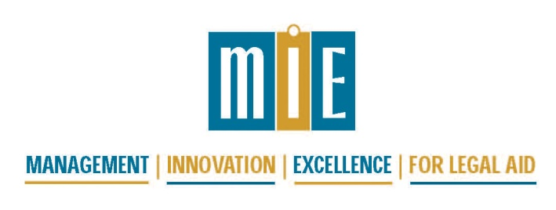

MIE 2018 National Fundraising Conference and
Voices for Civil Justice Third Annual National Communications and Media Training
July 25-27, 2018, Los Angeles, California

Agenda Draft 6/18/18

Tuesday, July 24, 2018
6:00 p.m. | Informal gathering of early arrivals – Meet at hotel bar, for drinks and to make dinner arrangements with colleagues

Wednesday, July 25, 2018
All day | Voices for Civil Justice Third Annual National Communications and Media Training  https://voicesforciviljustice.org/voices-blog/2018/05/join-us-in-los-angeles-for-the-3rd-annual-voices-national-media-communications-training/
6:00 p.m. | Informal gathering of attendees – Meet at hotel bar, for drinks and to make dinner arrangements with colleagues

Thursday, July 26, 2018
7:15 – 8:30 am | Registration, Continental Breakfast
8:30 – 9:00 am | Plenary – Welcome to the MIE 2018 Fundraising Conference
9:00 – 10:30 am | Plenary – Own Your Expertise, presented by Katie Orenstein, Founder and CEO of The Op-Ed Project
10:30 – 10:45 am | Break
10:45 – 12:15 pm | Leading for Fundraising Success: A Seminar for Executive Directors and Other Management Staff  [Skills Development] |  | Path to Federal, State and Local Funding through Community and Government Partnerships  [For All] |  | Structures for Engaging Volunteer Leaders in Fundraising – A Conversation with Legal Aid Leaders Who Have Implemented Options  [More Advanced] |  | Messaging to the Middle....or Not  [For All]
12:15 – 1:45 pm | Lunch
1:45 – 3:15 pm | Building Blocks for Successful Private Fundraising  [Skills Development] | Raising more from law firms  [For All] |  | Purposeful Events  [For All] |  | Make Every Day a Campaign Day: Top 10 Reasons Why Any Type of Campaign Will Boost Your Fundraising Program  [More Advanced]
3:15 – 3:30 pm | Break
3:30 – 5:00 pm | You’re Only as Good as Your Plan  [For All] | Foundations  [Skills Development] |  | Breaking into the non-attorney individual market  [For All] |  | Affinity Groups:  -Collaborative campaigns  -One-person Development Departments  -Celebrating Anniversaries
6:00 – 7:30 pm | Reception at new headquarters of Legal Aid Foundation of Los Angeles

Friday, July 27, 2018
 | 7:30 – 9:00 am | Continental Breakfast
 | 8:00 – 9:00 am | 30 Minutes with a Mentor (must sign up in advance)
 | 9:15 – 10:30 am | Plenary – 2020 Giving Forecast: A look at significant shifts in giving and future philanthropic and societal trends that are shaping how we give and how our nonprofits must adjust. (With special focus on individual donors.) Presented by Aly Sterling
 | 10:30 –10:45 am | Break
 | 10:45 –12:15 pm | Cultivating and stewarding donors  [More Advanced] | Roundtables:  -Cy Pres  -LSC Issues in Fundraising  -State Legislative Funding | Getting to a board that works for fundraising  [Skills Development] |  | The New Tax Law and its Impact on Fundraising  [For All]
 | 12:15 – 1:45 pm | Lunch
1:45 – 3:15 pm |  | Mini-plenary:  Brush Up Your Asking Skills and Encourage Volunteers to Do the Same  [For All] |  | Different Generations: What You Need to Know and Do to Raise Money from Each of Them  [For All] | Using Social Media to Move People to Action  [For All]
3:15 – 4:00 |  | Wind-down time in the hotel bar, for those with some time before their plane flights!

