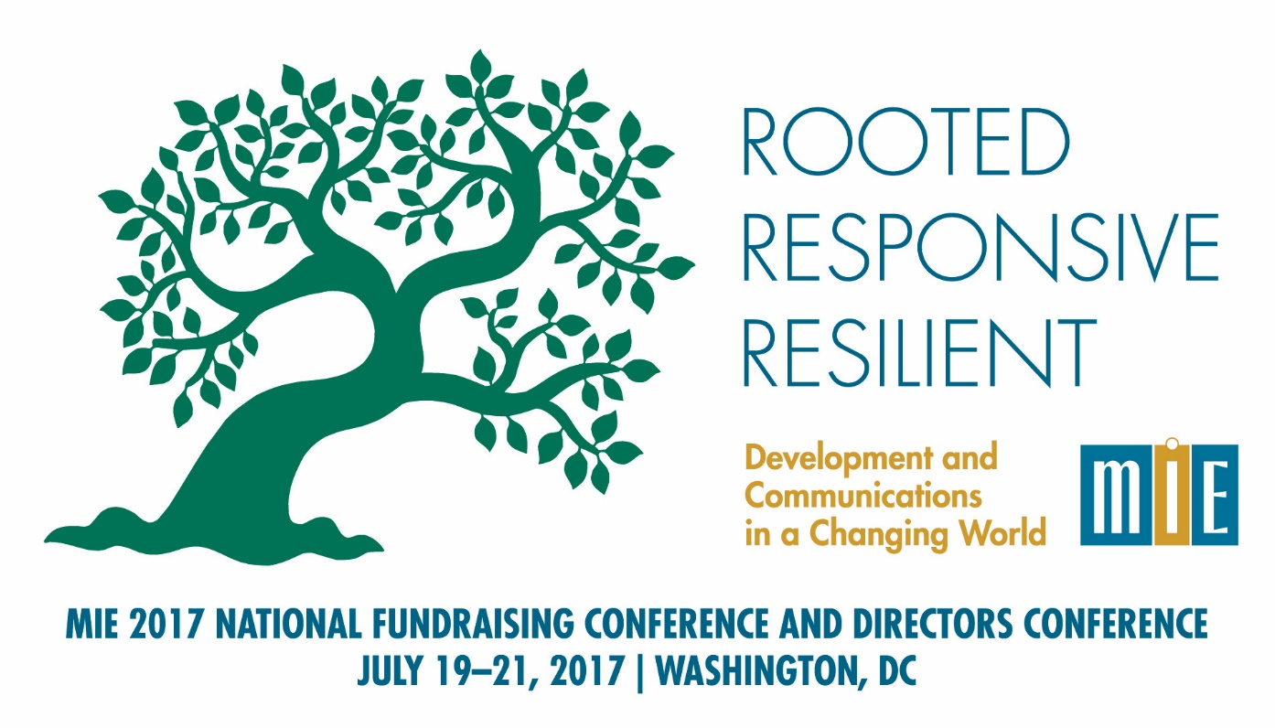
Draft Agenda 6/12/17

Tuesday, July 18, 2017
6:00 pm | Informal gathering of early arrivals – Meet at hotel bar, for drinks and to make dinner arrangements with colleagues

Wednesday, July 19, 2017
7:30 am –  5:00 pm | Voices for Civil Justice 2017 National Communications Training  7:30 am Registration and Continental Breakfast  8:30 am Training Starts
1:00 – 5:00 pm | Leading for Fundraising Success: An MIE Seminar for Executive Directors  (separate registration)
6:00 pm | Informal gathering of attendees – Meet at hotel bar, for drinks and to make dinner arrangements with colleagues

Thursday, July 20, 2017
7:00 – 8:00 am | First-timers Registration, Continental Breakfast
8:00 – 8:30 am | Plenary - Welcome to the Fundraising Conference and Directors Conference
8:30 – 10:30 am | Plenary – Change the Story, Change the World, by Andy Goodman, part 1
10:30 – 11:00 am | Break, snacks
11:00 – 1:00 pm | Plenary – Change the Story, Change the World, by Andy Goodman, part 2
1:00 – 2:30 pm | Enjoy Lunch with a Colleague
2:30 – 4:00 pm | Starting a Private Fundraising Campaign in Legal Aid | Major Gifts – Nuts and Bolts | Non-LSC Federal Funding | Executive Directors and Development Directors Working Together to Raise Money More Effectively | Directors Conference – Succession Planning – It Is Not Just about the Executive Director – Preserving Relationships with Donors, Funders and Partners
4:00 – 4:15 pm | Break
4:15 – 5:45 pm | Identifying and Cultivating Individual Donors | Major Gifts – In Practice in Legal Aid | Data Management 101 | For Development Directors New to Legal Aid | Directors Conference - Managing Multiple Funding Sources from Application to Audit: You Want Me to Account for What??
6:00 pm | Informal gathering for drinks. Dinner on your own, or sign up for one of the “dinner groups” that will be announced and organized at the Thursday morning plenary.

Friday, July 21, 2017
 | 7:30 – 9:00 am | Continental Breakfast
 | 8:00 – 8:45 am | 30 Minutes with a Mentor (must sign up in advance)
 | 9:00 – 10:45 am | Plenary: Celinda Lake, Lake Research Partners – Findings of 2017 Messaging Research conducted for Voices for Civil Justice and the National Association of IOLTA Programs
 | 10:45 –11:00 am | Break
 | 11:00 –12:30 pm | Foundations | Legal Community Fundraising and Pro Bono |  | Using Data Results to Improve Effectiveness |  | Maximizing Board’s Reach – Responsibilities of Executive Directors and Development Directors |  | Directors Conference – The Challenges of Working in Partnerships
 | 12:30 – 2:00 pm | Enjoy Lunch with a Colleague
2:00 – 3:30 pm |  | Training Your Board and Everyone in Making the “Ask” |  | Fundraising Beyond the Legal Community |  | Building an Effective Development Department – What Executive Directors Need To Know |  | Directors Conference - Internal Communications – Roundtable and Best Practices
3:30 – 4:00 pm |  | Wind-down time in the hotel bar, for those with some time before their plane flights!

