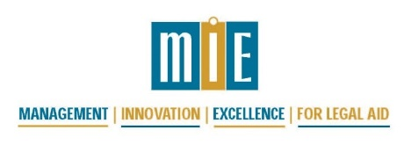
Strengthen your Core —
A Virtual Training for Supervisors of Legal Work
presented by MIE and CORT*
March 24 - 26, 2021, starting at Noon Eastern each day

March 24, 2021 12:00 – 5:30 pm Eastern Time
12:00 – 12:45 pm | Welcome and Overview, The Core Duties of Legal Aid Managers
1:00 – 1:55 pm | Supervision Systems
2:10 – 3:00 pm | Building Effective Supervision Systems
3:15 – 4:15 pm | Peer Group Discussions and Exercises– Supervision Systems
4:30 – 5:30 pm | Retaining a Quality Staff and Building a Culture of Professional Development

March 25, 2021 12:00 – 5:30 pm Eastern Time
12:00 – 1:00 pm | Difficult Conversations and Effective Feedback
1:15 – 2:00 pm | Peer Group Discussions– Difficult Conversations and Effective Feedback
2:15 – 3:15 pm | Project Management
3:30 – 4:00 pm | Work Plans, Making Them Work for You
4:15 – 5:30 pm | Peer Group Discussions – Project Management and Work Plans

March 26, 2021 12:00 – 5:00 pm Eastern Time
12:00 – 1:30 pm | Race Equity Workshop: Power Structures and White Dominant Workplace Culture
2:00 – 3:30 pm | Race Equity Workshop: Inclusive Supervision
3:45 – 5:00 pm | Leadership and Leading Change

*MIE is co-sponsoring this training with the Ohio, Michigan, West Virginia and Indiana Region IV Committee on Regional Training (CORT).

