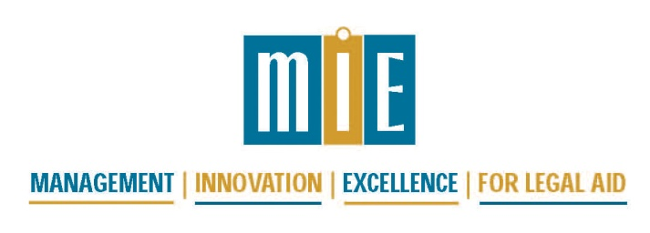

Advance Beyond the Basics
Supervising for Excellence
September 24 - 26, 2018
Columbus Ohio

Monday, September 24, 2018
8:00 – 9:00 am | Registration meeting room 30
9:00 – 9:15 am | Welcome and Introduction of Trainers, Conference Overview  Eric Mittelstadt
9:15 – 10:15 am | 9:15 – 9:45 Keynote Speaker  Professor Nancy Hardin Rogers  Professor Emeritus of Law; Director, Program on Law and Leadership  The Ohio State University, Moritz College of Law  9:45 – 10:15 Opening Remarks: Moving Beyond The Basics: Strengthening our Leadership, Management and Supervision to Deliver Great Legal Services  Gene King, Joanna Otero, Robert Bush
10:15 – 10:30 am | Break
10:30 – 12:00 pm | Small Groups: Introductions, Participant’s Goals for Training
12:00 pm - 1:30 pm | Lunch, on your own
1:30 - 3:30 pm | Large Group Lecture and Demonstration: Managing Cross Cultural Conflict. Difficult Conversations and Implicit Bias in Supervision.  Kwame Christian  Director, American Negotiation Institute
3:30 - 3:45 pm | Break
3:45 - 5:00 pm | Small Groups: Discussion/Role Plays re: Managing Cross Cultural Conflict

Tuesday, September 25, 2018
8:00 – 9:00 am | Continental Breakfast
9:00 – 10:15 am | Large Group Presentation: High Quality Supervision and Small Group: High Quality Supervision  Margaret Moores, Michelle Johnson
10:15 - 10:30 am | Break
10:30 – 12:00 pm | Small Group: Supervision Standards and High Quality Supervision
12:00 - 1:30 pm | Lunch, on your own
1:30 - 2:30 pm | Large Group Presentation: Creating Effective Teams and Project Planning  Gene King, Dennis Harrington, Jerel McCrary
2:30 – 3:00 pm | Break
3:00 - 5:00 pm | Small Group: Creating Effective Teams and Project Planning: Exercises to Take Home

Wednesday, September 26, 2018
8:00 - 9:00 am | Continental Breakfast
9:00 - 9:45am | Large Group Presentation: Professional Development and Evaluation  Tanya Douglas, Tom Mlakar
9:45 - 11:30 am | 9:45 – 10:45 Small Groups: Professional Development Exercises  10:45 – 11:30 Small Groups: Round Table on Supervision Issues
11:30 - 12:45 pm | Large Group Presentation, Discussion and Exercises: Leading Change  Clint Adams

During the training, share and connect on social media with the #AdvanceBeyond2018
(Find MIE on Twitter and Facebook!)
After the training, visit the MIE Trainings and Conferences/2018 Advance Beyond the Basics: Supervising for Excellence section of the MIE online library to access materials from the sessions.

