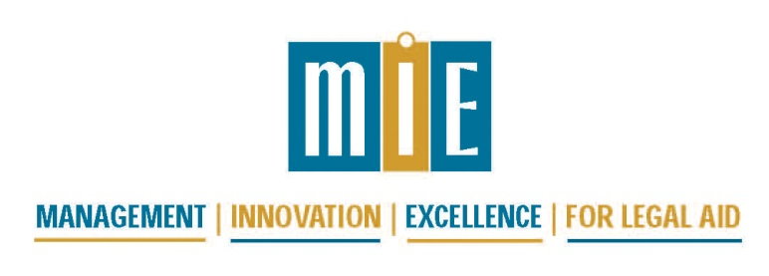

2013 National Conference for Legal Services Administrators

January 15 and 16, 2013, Jacksonville, FL

Draft Agenda

Monday, January 14, 2013
6:00 pm | Opening Night Informal Gathering, Please join us in the hotel lounge for a drink and networking for dinner

Tuesday, January 15, 2013
7:30 – 8:30 am | Registration and Continental Breakfast
8:30 – 10:00 am | Plenary Session: Sustainability, by Shannon Ellis, CompassPoint Nonprofit Services
10:00 – 10:30 am | Break
10:30 – 11:45 am | Sustainability Clinic: Making the Hard Decisions for Financial Viability  (Please commit to participating to this as a full day session, no in and out) | HR and Office Management Roundtable
11:45 – 1:45 pm | Lunch
1:45 – 3:00 pm | Sustainability Clinic: Making the Hard Decisions for Financial Viability, continued | Tech-fficiencies for Administrators
3:00 – 3:30 pm | Break
3:30 – 4:45 pm | Sustainability Clinic: Making the Hard Decisions for Financial Viability, continued | Surfs Up! for Outcome Measures and Client Input
5:00 pm | No-host “gathering,” – Please join us in the hotel lounge for a drink and networking for dinner

Wednesday, January 16, 2013
7:30 – 8:30 am | Continental Breakfast
8:30 – 10:00 am | Plenary: The Networked Nonprofit, by Beth Kanter
10:00 – 10:30 am | Break
10:30 – 11:45 am | Financial Oversight and Internal Controls | Supervision and Your Case Management System
11:45 – 1:45 pm | Lunch with James J. Sandman, President, Legal Services Corporation
1:45 – 3:00 pm | Grant Writing Tips and Tools | Choose from these TIG conference sessions:  ~How to Pull Your Case Management System out of the 80s  ~How Not to Write Content for your SWWS  ~Managing Choices With and About Technology  ~ 2012 TIG Evaluation Planning Session
3:00 – 3:30 pm | Break
3:3 0 – 4:45 pm | Fiscal Roundtable | Choose from these TIG conference sessions:  ~Video to Reach Clients  ~Windows 8 and Office 2013  ~”Big Data” and Legal Services
5:00 - 6:00 pm | Networking and Affinity Groups

