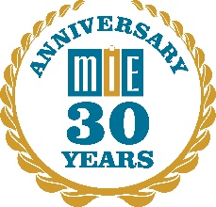

MIE National Conference for Legal Services Administrators

January 12 and 13, 2016
Wyndham San Antonio Riverwalk

Draft Description of Sessions 11/19/15

The Employment Law Update: ACA reporting, changes in overtime rules, and more

Social Media as a Communications Strategy: powerful internal and external uses, identifying audiences and goals

Reasonable Accommodations: HR issues, ADA, wellness, ergonomics. A panel discussion.

Essential Staff May Soon Retire – What Do We Do To Preserve Their Knowledge?: Transition planning for all key staff, developing the next generation of leaders

Data Breaches – Protecting client records, bank records; cyber insurance coverage, liabilities

Retention Issues – A Facilitated Plenary Discussion: How to keep talent and diversity; local and statewide solutions; rural and urban solutions; salaries, stagnation and stress, telework

Data – How to Get Good Data into the System and How To Present It to Managers and Boards

Paperless Administration – achieving full functionality, AP, signing checks, electronic signatures for clients

HR Roundtable with a Focus on the Skills and Training an HR person Needs, outsourcing as a supplemental strategy

