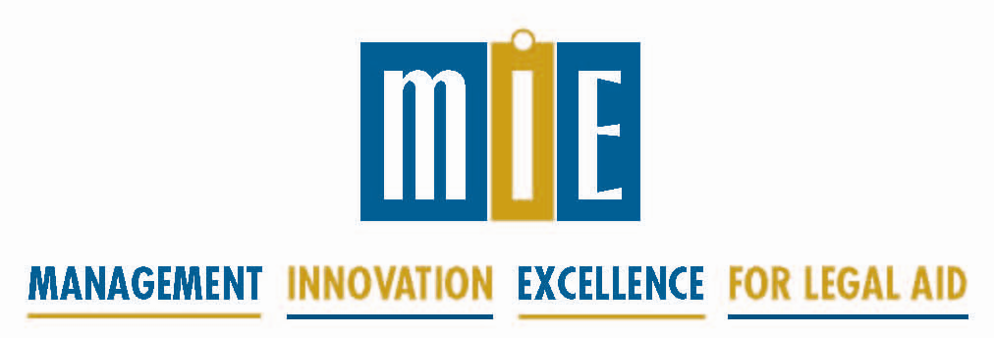

New Executive Director Training

Tuesday, May 10 and Wednesday, May 11, 2016
8:30 am - 5:00 pm

Immediately preceding the ABA/NLADA Equal Justice Conference
at the Palmer House Hilton Chicago

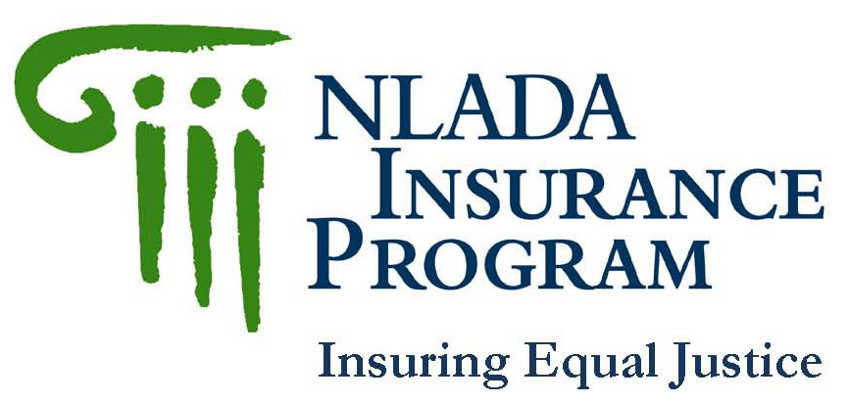
Sponsored by:

This two day training is newly updated and more relevant than ever to the challenges facing the legal aid executive director today. It is designed for the new directors of LSC-funded, IOLTA-funded, elder law, pro bono and protection and advocacy programs.

The intent of the New Executive Director training is to help new directors, who typically learn on-the-job, to more quickly achieve deeper insight into their work. The training stresses both 1) knowing what should be done to lead an effective program, and 2) actually doing what needs to be done.

Trainers will include MIE Board Members Jan May, Executive Director, AARP Legal Counsel for the Elderly, and Jacquelynne Bowman, Executive Director, Greater Boston Legal Services, and Patricia Pap, MIE Executive Director.

For registration and payment information, visit http://mielegalaid.org/

For hotel information, visit http://www.americanbar.org/groups/probono_public_service/ejc/hotel_accomodations.html

-------------------------------------------------------------------------------------------- MIE New Executive Director Training Registration
Please register by April 13, 2016

Name/Title: |  |  | Fax:
Program Name: |  |  | Email:
Address: |  |  | Registration Fees: □ MIE subscribers $365 □ Non-subscribers $465  Please send registration and check to address below or visit www.mielegalaid.org to complete the registration form on line and pay by credit card. For more info, contact Patricia Pap, MIE Executive Director at ppap@m-i-e.org or 617.556.0288.
City:
State: | Zip:
Phone:
